Title
Author¹, Author², Author^{3*}
¹Affiliation with mailing address
²Affiliation with mailing address
³ State Key Laboratory of Solid Lubrication, Lanzhou Institute of Chemical Physics,
Lanzhou 730000, China
*E-mail: wangxl@licp.cas.cn

Keywords: 3-5 keywords separated by a comma

ABSTRACT
Abstract should be succinct to reflect the contents of your presentation in not less than 200 words. Graphics (table or figure) are recommended. Key references can be cited in the abstract using the nature style¹.
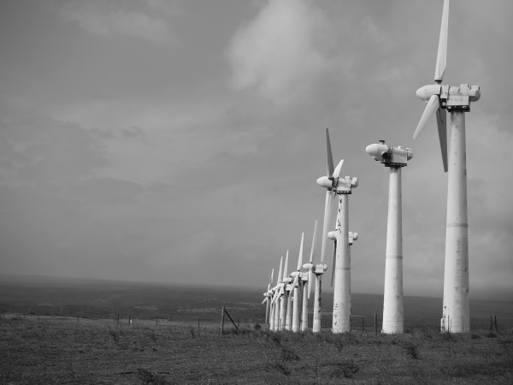
Fig 1. An array of wind turbines in rural countryside.

REFERENCES
1 Hofstätter, T., Pedersen, D. B., Tosello, G. & Hansen, H. N. State-of-the-art of fiber-reinforced polymers in additive manufacturing technologies. Journal of Reinforced Plastics and Composites 36, 1061-1073, doi:10.1177/0731684417695648 (2017).

Biography
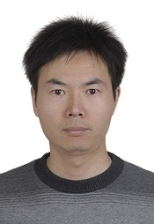
Your biography should be provided here. It will be better to upload a photography as shown in the right. Dr. Xiaolong Wang is a full Professor in Lanzhou Institute of Chemical Physics (LICP), CAS. He joined the LICP at 2007 when he got his PhD in the major of polymer chemistry and physics at Lanzhou University. During his stay in LICP, he spent a year (2010-2011) in Hong Kong Polytechnic University as a Research Associate and two years (2011-2013) in University of Western Ontario (Canada) as a visiting professor. His research interests are biomimetic lubrication, 3D printing, functional soft materials, and printing electronics. He has published more than 50 papers in peer-reviewed international journals including Adv. Mater., Angew. Chem. Int. Ed., Chem. Commun., and J. Mater. Chem., etc., which have already got more than 1000 citations.

